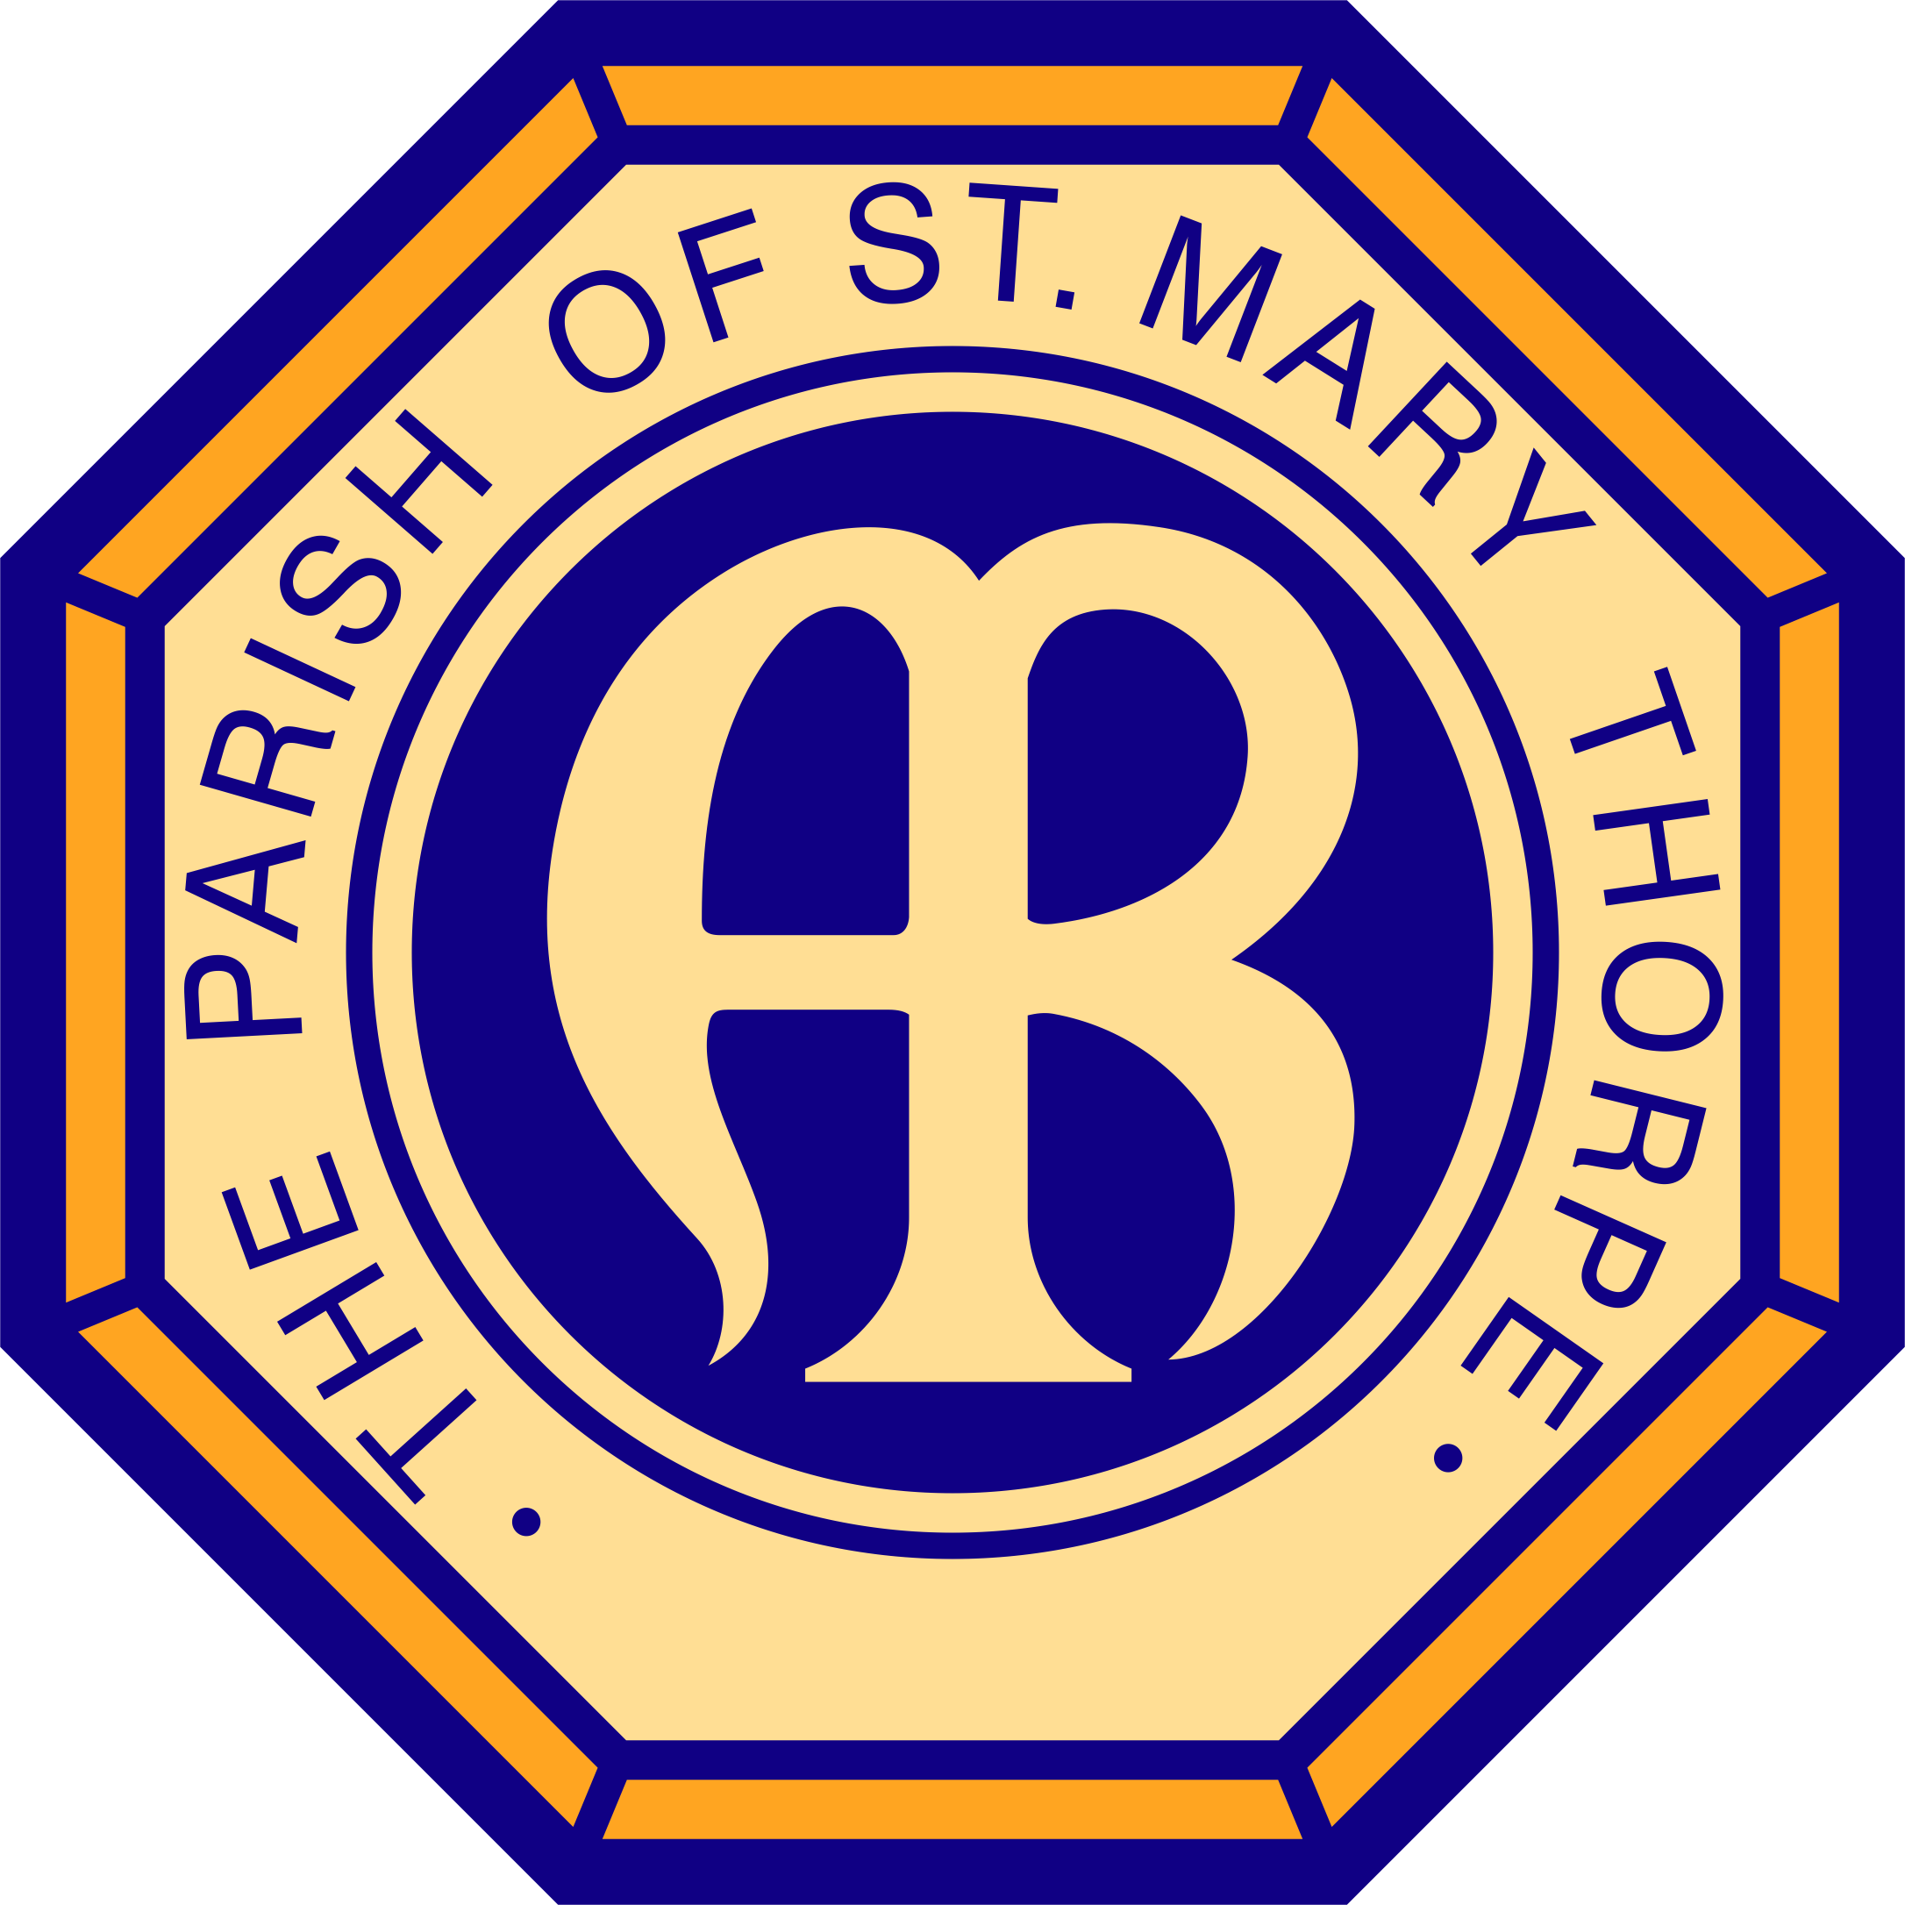
Faith Confirmed 2019

Welcome Session & Introduction: Living stones

Leaders for 2019
This year we have four leaders for our Faith Confirmed Course:
Damian, our Vicar, assisted by Jo Winn-Smith who was made Deacon and joined the clergy team in June, Gerard our assistant Curate who works full time in secular employment and Andrew our occasional preacher.

The Church of St Mary, Thorpe
- Our Church building is over 1000 years old
- A Church first stood on this site in the 700’s
- The present Church originates from the 11th Century
- The Norman Arch and pillars are some of the oldest stonework
- The Hall (Rutherwyke Room) was built in the 1980’s and extended in 1999
- In 2018 our average Sunday attendance was 70 adults and 10 children
- Our Church Roll was 144
- There is always a warm welcome for all at St Mary’s.

Christians, part of the wider Church of God
The foundation and cornerstone of the Church community is the person and work of Jesus Christ. We gain the name Christian from him, who is the best way to get to know God. Jesus alone is the living stone upon which the whole church world-wide, including our St Mary’s here in Thorpe is built, and from our church communities – fathered Christians and those exploring faith, we advance his Kingdom mission.

To be a Christian is to be a part of this reality, that we exist together as living stones. There simply is no other kind of Christianity, as Peter, who was one of Jesus’ first followers teaches in his first letter found in the New Testament:

“Come to him, a living stone, though rejected by mortals yet chosen and precious in God’s sight, and like living stones, let yourselves be built into a spiritual house.” (1 Peter 2. 4-5)

Stones!
When we look at stones, we are struck by the uniqueness of each. Why not take a careful look at a stone or pebble now... look carefully and try and describe it! How does it feel? It may be thousands, even millions of years old. It is now in your hand – you have it; unique, wonderful and special in God’s sight, just as you are. Stones build foundations. Our church building has stones which have been arranged in this formation for over 1000 years, a place where many generations of people have gathered to pray, to worship, to study, to learn, to break bread and celebrate (and even party!)

Our Church is therefore like gathered stones, our faith like a foundation on which our family can be together and enjoy life, sharing so much of life’s joys and our troubles as we journey together. This shared journey makes St Mary’s an exceptionally special place – a spiritual home.

We are unique and special to God
Each of us is unique. We come with different gifts and talents, abilities, likes and dislikes - and thank heavens for that. What a dreadfully dull and boring place St Mary’s would be without you! So, thank you for being here. Thank you for being you. As we explore faith together may we respect our differences and our confidentiality. If something is shared in the group let it remain here.

We won’t and don’t all agree on everything! A common misconception about the Christian faith is that our religion is all about making us all think or do things the same way all the time. That couldn’t be further from the truth. Out faith is about liberation; being called into God’s presence through our worship (and socialising) that we may become the very best people, the people God is calling us to be, both in our uniqueness and also corporately, built into one family – the family of faith - fellowship. Therefore, this church – St Mary’s – Jesus - needs you!

Faith Confirmed – a journey
Christians believe the church is the body of Christ and proclaims Jesus to the world and that each person in the body is uniquely called and gifted for ministry; to be living stones. The church, our faith family sustains us for life’s journey and the many challenges we face. Next week we will think more about what it means to be a part of the Church family, some of the history behind who we are and what we believe; why we are inclusive of all and how that is about building community, the body of Christ.

Then each following session we will explore different aspects of Christian faith, from creation to our relationship with God, Jesus and his life, death and resurrection, the Holy Spirit, the Bible, Holy Communion and prayer, healing, confirmation, baptism and some moral issues too. There will be opportunities for discussion and conversation, for silence, prayer, some bible study and much more. We haven’t covered absolutely everything, but we are very happy to touch on all sorts of topics as we go along – just ask! There is also more in the course book, ‘Faith Confirmed’ which we hope you will read in your own time.

Confirmation Service for Runnymede Deanery Autumn 2019
For those already wanting to make a commitment to God, there is a Confirmation Service at St John’s Egham on Sunday 3rd November at 6.30pm. There is no obligation to be confirmed - no rush! Just take time to explore Christianity. As the words from the first letter of Peter reminded us at the beginning:

“Come to him, a living stone, though rejected by mortals yet chosen and precious in God’s sight, and like living stones, let yourselves be built into a spiritual house.” (1 Peter 2. 4-5)

