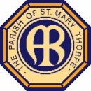
Faith Confirmed 2019
THINKING ABOUT LIFE AFTER DEATH
You can be sure of both death and taxes!
Death is usually understood as the cessation of vital functions in an organism, resulting in the termination of life, and it is the one thing we can be sure of. Everything else may or may not happen to us: we might get married, be rich or be happy, but all these are 'might’s'. The only real certainty is that at the end of our life, whenever that is, we will all die. However, to say that at death life in all its fullness ends is somewhat misleading – even if it can feel just like that for those who live with bereavement. Today, death is often wrongly viewed as failure, as people say 'they lost their battle with cancer' without recognising the fragility and miracle that life is. Indeed, for most of the time our natural inclination is to fight to survive; against infections, diseases, hunger, safety and so on.

In religious literature and teachings, a distinction is commonly made between the body and the soul (sometimes described as the spirit) and with this the accompanying belief that whilst the body will inevitably die, the soul can move on into another reality. Christianity is no exception, recognising that there is a distinction between the body, the temple in which we dwell for our life, and the soul, the part of us that communicates love, and is called to be in relationship with God. This is the part of us that usually drives us to live and survive.

The Fall – sin and all that gets in the way of life
The book of Genesis records an account of the first human fall from grace, when Adam and Eve disobeyed God in the Garden of Eden, partaking of the apple from the tree of all knowledge, the fruit they were forbidden to eat (tricked into tasting by the serpent). It is understood that their sin, a decision to disobey God’s command, led to a separation. Therefore, sin is seen as us choosing to separate ourselves from God, because with full knowledge of our fragility comes knowledge of our mortality. (See Genesis 3) The fall is known as original sin (the sin of Adam and Eve) and the consequence for humanity in Genesis is mortality with separation from God the worst outcome found in scripture.

In early Hebrew religious thought people believed that when somebody died, they went to a dark place under the earth called Sheol, as the psalmist writes:
‘The wicked shall depart and go down to Sheol.’ (Psalm 9: 17)

Later, as the Hebrew faith developed into Judaism, people began to believe that they might share some sort of eternal life with God after death, hence the importance of burying the dead whole ready for the day they would be bodily raised by God. Jesus’ teaching is different again. He was the one without sin, who gave up his life and overcome death with new life, that everyone who believes in him may live.

“Everything that the Father gives me will come to me, and anyone who comes to me I will never drive away; for I have come down from heaven, not to do my own will, but the will of him who sent me. And this is the will of him who sent me, that I should lose nothing of all that he has given me but raise it up on the last day. This is indeed the will of my Father, that all who see the Son and believe in him may have eternal life; and I will raise them up on the last day.” (John 6. 37-40)

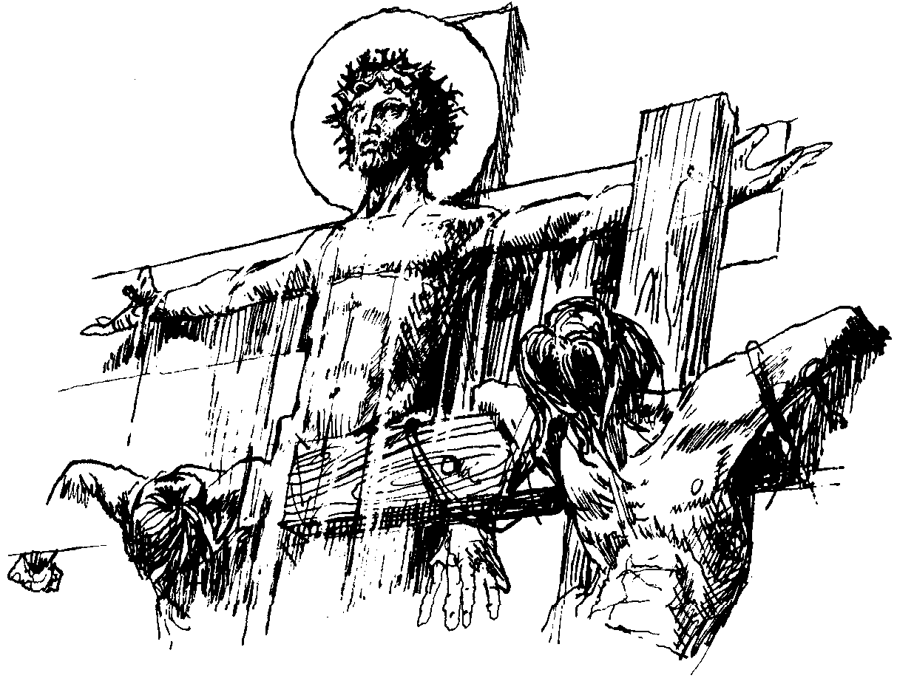
That is why there is a different understanding of heaven in the Old Testament from that inaugurated by Jesus in the New. Yes, human beings are not immortal, and life is transient, and our bodies will eventually die. But Jesus offers eternal life, for our soul. For when he died on the cross he gave up his life, wiping our failures aside and demonstrating the absolute love of God. Then he rose from the dead, proving that it was possible to overcome death with new life and therefore live with God for all eternity. His death on the cross and new life in the resurrection are key to Christian thinking about life after death. By Jesus’ love in action, Christians are freed from the burden of original sin if they follow his teaching and example and believe in him as the Son of God. Jesus said:

“I am the resurrection and the life. He who believes in me will live, even though he dies.” (John 11:25-26)
From the cross Jesus says to the penitent criminal:
“Truly, I tell you, today you will be with me in paradise.” (Luke 23:43)

Jesus will come again to judge the living and the departed
The Second Coming (sometimes called the Second Advent or the Parousia – in Greek παρουσία, meaning "arrival", "coming", or "presence") is a belief regarding the future return of Jesus. Many Christians believe that one day Jesus will return to earth. Some suggest this is when he will judge everyone and decide whether they will be given eternal life with God or whether they are to be punished in hell, based on literal readings of the messianic prophecies found in the Gospels. Therefore, the Nicene Creed includes:
‘… in accordance with the Scriptures; he [Jesus] ascended into heaven and is seated at the right hand of the Father. He will come again in glory to judge the living and the dead, and his kingdom will have no end.’
The Book of Common Prayer describes Jesus judging ‘The quick and the dead.’ Indeed, Jesus dramatically foretells such an event in Matthew’s Gospel when he says:
“For as the lightning comes from the east and flashes as far as the west, so will be the coming of the Son of Man.” (Matthew 24:27)
There is an element of mystery about all of this, which is why in the middle of the Eucharistic Prayer we proclaim the ‘mystery of faith’ saying:
"Christ has died, Christ is risen, Christ will come again."

What about Heaven and Hell?
Christians have various ideas about heaven and hell, largely drawn from the scriptures and in particular the Book of Revelation – the last book of the New Testament. One view is that heaven is a wonderful garden paradise where we can live with God, Jesus and those whom we love but see no longer who are already there. The contrasting place to heaven is therefore hell, where the unrepentant sinner suffers eternal torment and punishment. Some believe that heaven and hell are really states of mind of happiness and unhappiness, experienced today while we live. Another view is that heaven is the condition of being permanently united with God and hell a condition where you are permanently unhappy and unable to be with God, separated from his love, by sin. Many Christians today believe our place in heaven is a gift that is solely God's to give, not something to be earned in this life. As Paul writes:
“For by grace you have been saved through faith, and this is not your own doing; it is the gift of God.” (Ephesians 2.8)

Purgatory
Some Christians (often Roman Catholic) believe that, as well as heaven and hell, there is an intermediate place called purgatory. It is thought that when people die many will go to purgatory; this is a compromise for non-believers who are too good for hell, a chance to work their way into heaven. Then, when all their failings have been forgiven, and when they believe in the promises of God through Jesus Christ, they too will go to heaven. Others simply understand purgatory as an intermediary state – a place between earth and heaven. We should remember that God’s time and ours is quite different - what we do know from the New Testament is that in God’s time the world will be judged, indeed Jesus tells us that it has already happened by his own coming among us, his incarnation:
“Now is the judgement of this world.” (John 12:31)

The day of judgement
Jesus talked about the day of judgement as a way of setting the world right. Simply, there is to be recompense for those who missed their fair share and whose goodness had gone unrewarded, and justice for those who had done wrong and got away with it:
‘When the Son of Man comes in glory and all the angels with him, then he will sit on the throne of his glory. All the nations will be gathered before him, and he will separate people one from another as a shepherd separates the sheep from the goats.’ (Matthew 25:31 & 32)
If this sounds very familiar, though, be warned. The stereotyped view of hell is reading an awful lot between lines that Jesus left blank. What he said on the subject was not so much to inform as to warn and encourage. It was probably more about the problems of his own day than a warning of what is to come. To sum it up: "its good news for the good and bad news for the bad. So, make sure you're on the right side – my side."

What do you believe about life after death? Jesus can help
None of us can ever know exactly what will happen when we die before that day, indeed much of this is a mystery. We do know that we must and will die sometime. That also means we will have to live with the real and difficult pain of loss: bereavement. This is because all our bodies are only able to last for a time, and just as we grow, and change, so we age, and everything must come to an end. We are reminded in Genesis that God tells Adam and Eve that they are made from the dust of the earth:
‘and to dust you shall return’. (Genesis 3:19) The same is true for all people, and we repeat these words on Ash Wednesday when the priest places black ash on our heads in the sign of the cross. The prayer of blessing over the ashes is said first:
God our Father, you create us from the dust of the earth: grant that these ashes may be for us a sign of our penitence and a symbol of our mortality; for it is by your grace alone that we receive eternal life, in Jesus Christ our Saviour. Amen.

The priest and people receive the imposition of ashes upon their heads with the words:
Remember that you are dust, and to dust you shall return.
Turn away from sin and be faithful to Christ.

Jesus can help us in the face of death and loss if we are willing to recognise our mortality and live, for with Jesus there is hope. Firstly, he promises the forgiveness of sins, and secondly, the pledge of a heavenly dwelling place for those who trust in him. Before his own death, Jesus knew that he must leave his disciples; he had to die, and so he offers them words of comfort and hope, that there is more than just earthly life:
“In my Father’s House, there are many dwelling places. If it were not so, would I have told you that I go to prepare a place for you. And if I go and prepare a place for you, I will come again and will take you to myself so that where I am there you may be also.” (John 14: 1-3)

In contrast to Jesus’ teaching there are those who say there is "one life, one death, and that's your lot." The New Testament shows us that Jesus thoroughly disagreed with this view. He teaches about the ‘Day of Resurrection’. We all die and in God’s time, we will all be reconciled back to the Father’s love which is all embracing and looks deep into our hearts as we are welcomed into paradise, liberated from all that held us back in life to live for his love. That is indeed the great mystery of our faith. And we can experience that heaven on earth now, in the Church, amidst the community of the faithful. In fellowship and Holy Communion, we come into the presence of Jesus in his time, and that means that through our sharing of the Eucharist we are re-united with those whom we love who go before us; the saints in heaven. How wonderful that thought is, that through Jesus’ greatest gift to us of the Sacrament of his Body and Blood, we can be reunited now with those who have gone before us. That really is something to live for.
The hope that Christianity offers
There are some very diverse thoughts within Christianity and beyond about this difficult subject. But Jesus’ words provide real hope to us, that after death, we can live on in God's presence and be with friends and family again, in a spiritual sense, as the soul is reunited with the creator who breathed life in the very first place, in the heavenly kingdom. As Christians we believe that the purpose for human existence is to serve our Creator God and care for the world over which He has given us dominion, and to be in relationship with Him and the world around us. Through a life of 'faith' one can receive salvation (salve = to be saved from death) and, by the grace of God, be rewarded with an eternal existence in heaven after death, in God’s time.
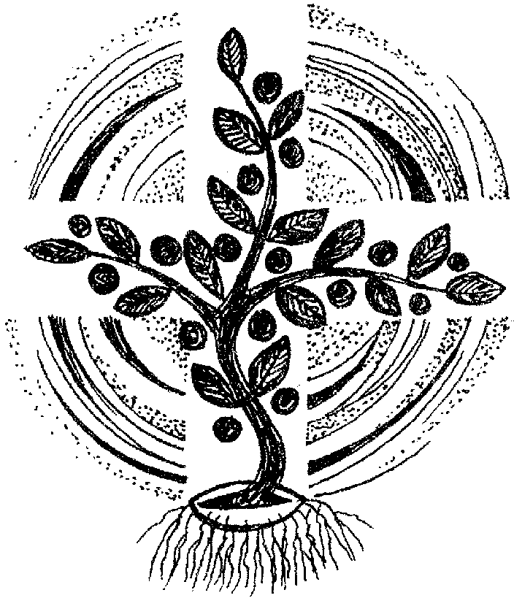

Support us, O Lord,
all the day long of this troublous life,
until the shadows lengthen and the evening comes,
the busy world is hushed,
the fever of life is over and our work is done.
Then, Lord, in your mercy grant us a safe lodging,
a holy rest, and peace at the last;
through Christ our Lord. Amen.
Merciful Father,
hear our prayers and comfort us;
renew our trust in your Son,
whom you raised from the dead;
strengthen our faith
that all who have died in the love of Christ
will share in his resurrection;
who lives and reigns with you,
in the unity of the Holy Spirit,
one God, now and for ever. Amen

THE SECOND COMING by William Butler Yeats (1865-1939)

Turning and turning in the widening gyre
The falcon cannot hear the falconer;
Things fall apart; the centre cannot hold;
Mere anarchy is loosed upon the world,
The blood-dimmed tide is loosed, and everywhere
The ceremony of innocence is drowned;
The best lack all conviction, while the worst
Are full of passionate intensity.

Surely some revelation is at hand;
Surely the Second Coming is at hand.
The Second Coming! Hardly are those words out
When a vast image out of Spiritus Mundi
Troubles my sight: a waste of desert sand;
A shape with lion body and the head of a man,
A gaze blank and pitiless as the sun,
Is moving its slow thighs, while all about it
Wind shadows of the indignant desert birds.

The darkness drops again but now I know
That twenty centuries of stony sleep
Were vexed to nightmare by a rocking cradle,
And what rough beast, its hour come round at last,
Slouches towards Bethlehem to be born?

The Second Coming was written in 1919 in the aftermath of the first World War.
The above version of the poem is as it was published in the edition of Michael Robartes and the Dancer dated 1920.

