ALL SOULS DAY YEARS A, B & C
2 NOVEMBER

HYMN
Dear Lord and Father of mankind,
Forgive our foolish ways!
Re-clothe us in our rightful mind,
In purer lives thy service find,
In deeper reverence praise.

In simple trust like theirs who heard,
Beside the Syrian sea,
The gracious calling of the Lord,
Let us, like them, without a word
Rise up and follow thee.

O Sabbath rest by Galilee!
O calm of hills above,
Where Jesus knelt to share with thee
The silence of eternity,
Interpreted by love!

Drop thy still dews of quietness,
Till all our strivings cease;
Take from our souls the strain and stress,
And let our ordered lives confess
The beauty of thy peace.

Breathe through the heats of our desire
Thy coolness and thy balm;
Let sense be dumb, let flesh retire;
Speak through the earthquake, wind, and fire,
O still small voice of calm!

PRAYERS OF PENITENCE
God has shone in our hearts to give the light of the knowledge of his glory in the face of Christ.
But we have this treasure in earthen vessels
to show that the transcendent power belongs to God and not to us. As we acknowledge our human frailty, we call to mind our sins of word, deed and omission, and confess them before God our Father.

Father eternal, giver of light and grace,
we have sinned against you and against our neighbour, in what we have thought,
in what we have said and done
through ignorance, through weakness,
through our own deliberate fault.
We have wounded your love
and marred your image in us.
We are sorry and ashamed
and repent of all our sins.
For the sake of your Son Jesus Christ,
who died for us, forgive us all that is past
and lead us out from darkness
to walk as children of light. Amen.

You raise the dead to life in the Spirit:
Lord, have mercy. Lord, have mercy.

You bring pardon and peace to the broken in heart:
Christ, have mercy. Christ, have mercy.

You make one by your Spirit the torn and divided:
Lord, have mercy. Lord, have mercy.

Almighty God, who forgives all who truly repent,
have mercy upon you,
pardon and deliver you from all your sins,
confirm and strengthen you in all goodness,
and keep you in life eternal;
through Jesus Christ our Lord. Amen.

COLLECT
The priest introduces a period of silent prayer:

Let us pray for the peace and well-being of the whole Church.

Eternal God, our maker and redeemer, grant us, with all the faithful departed, the sure benefits of your Son’s saving passion and glorious resurrection, that in the last day when you gather up all things in Christ, we may with them enjoy the fullness of your promises; through Jesus Christ our Lord, who is alive and reigns with you, in the unity of the Holy Spirit, one God, now and for ever. Amen.

FIRST READING Lamentations 3. 17-26, 31-33
A reading from the Lamentations of Jeremiah.
My soul is bereft of peace; I have forgotten what happiness is; so I say, ‘Gone is my glory, and all that I had hoped for from the Lord.’ The thought of my affliction and my homelessness is wormwood and gall! My soul continually thinks of it and is bowed down within me. But this I call to mind, and therefore I have hope. The steadfast love of the Lord never ceases, his mercies never come to an end; they are new every morning; great is your faithfulness. ‘The Lord is my portion,’ says my soul, ‘therefore I will hope in him.’ The Lord is good to those who wait for him, to the soul that seeks him. It is good that one should wait quietly for the salvation of the Lord. For the Lord will not reject for ever. Although he causes grief, he will have compassion according to the abundance of his steadfast love; for he does not willingly afflict or grieve anyone. This is the Word of the Lord. Thanks be to God.

PSALM Psalm 23

R The souls of the righteous
are in the hand of God.

The Lord is my shepherd; I shall not want.
He makes me lie down in green pastures
and leads me beside still waters. R

He revives my soul and guides me
along right pathways for his name’s sake.
Though I walk through the valley of the shadow of death, I shall fear no evil; for you are with me;
your rod and your staff, they comfort me. R

You spread a table before me
in the presence of those who trouble me;
you have anointed my head with oil
and my cup is running over.
Surely goodness and loving mercy shall follow me
all the days of my life,
and I will dwell in the house of the Lord for ever. R

SECOND READING 1 Peter 1. 3-9
A reading from the First Letter of Peter.
Blessed be the God and Father of our Lord Jesus Christ! By his great mercy he has given us a new birth into a living hope through the resurrection of Jesus Christ from the dead, and into an inheritance that is imperishable, undefiled, and unfading, kept in heaven for you, who are being protected by the power of God through faith for a salvation ready to be revealed in the last time. In this you rejoice, even if now for a little while you have had to suffer various trials, so that the genuineness of your faith—being more precious than gold that, though
perishable, is tested by fire—may be found to result in praise and glory and honour when Jesus Christ is revealed. Although you have not seen him, you love him; and even though you do not see him now, you believe in him and rejoice with an indescribable and glorious joy, for you are receiving the outcome of your faith, the salvation of your souls. This is the word of the Lord. Thanks be to God

ALLELUIA
Alleluia, alleluia. ‘It is the will of him who sent me,’ says the Lord, ‘that I should lose none of all that he has given me, but raise them up on the last day.’
Alleluia! cf John 6.39
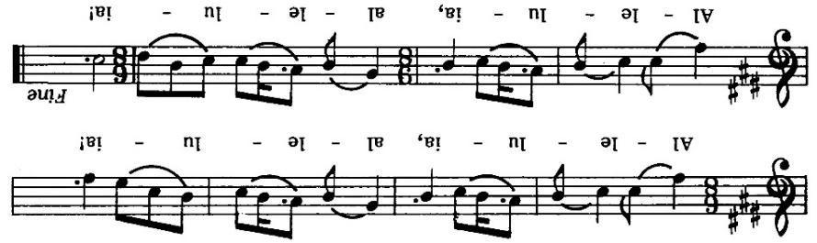

GOSPEL John 6: 37-40
Hear the gospel of our Lord Jesus Christ according to John. Glory to you O Lord.
Jesus taught, ‘Everything that the Father gives me will come to me, and anyone who comes to me I will never drive away; for I have come down from heaven, not to do my own will, but the will of him who sent me. And this is the will of him who sent me, that I should lose nothing of all that he has given me, but raise it up on the last day. This is indeed the will of my Father, that all who see the Son and believe in him may have eternal life; and I will raise them up on the last day.’ This is the Gospel of the Lord. Praise to you, O Christ.

INTERCESSIONS & COMMEMORATION
Let us pray to the Lord, who has conquered death.

Hear us, risen Lord.
Our resurrection and our life.

Following short prayers, the names of those to be remembered are read aloud. Silence is kept after each group of names.

Jesus said, “This is the will of him that sent me,
that I should lose nothing of all that he has given me, and I will raise them up at the last day.”

Lord God, creator of all, you have made us creatures of this earth, but have also promised us a share in life eternal. According to your promises,
may all who have died in the peace of Christ
come with your saints to the joys of your kingdom,
where there will be neither sorrow nor pain,
but life everlasting. Merciful Father…

THE PEACE
Jesus says: Peace I leave with you;
my peace I give to you. Not as the world gives
do I give you. Do not let your hearts be troubled,
neither let them be afraid.

The peace of the risen Lord be always with you.
And also with you.

Let us offer one another a sign of peace.

HYMN
Let all mortal flesh keep silence,
and with fear and trembling stand;
ponder nothing earthly-minded,
for with blessing in his hand,
Christ our God to earth descendeth,
our full homage to demand.

King of kings, yet born of Mary,
as of old on earth he stood,
Lord of lords, in human vesture,
in the body and the blood,
he will give to all the faithful
his own self for heav'nly food.

Rank on rank the host of heaven
spreads its vanguard on the way,
as the Light of light descendeth
from the realms of endless day,
that the pow'rs of hell may vanish
as the darkness clears away.

At his feet the six-winged seraph,
cherubim, with sleepless eye,
veil their faces to the presence,
as with ceaseless voice they cry,
"Alleluia, alleluia, alleluia, Lord Most High!"

OFFERTORY PRAYER
As the grain once scattered in the fields and the grapes once dispersed on the hillside are now reunited on this table in bread and wine, so, Lord, may your whole Church soon be gathered together from the corners of the earth into your kingdom. Amen. or
Look upon us in mercy not in judgement;
draw us from hatred to love;
make the frailty of our praise
a dwelling place for your glory. Amen.

PROPER PREFACE
Father, all-powerful and ever-living God,
we do well always and everywhere to give you thanks through Jesus Christ our Lord.

In him, who rose from the dead,
our hope of resurrection dawned.
The sadness of death gives way
to the bright promise of immortality.

Lord, for your faithful people life is changed,
not ended. When the body of our earthly
dwelling lies in death we gain an everlasting dwelling place in heaven.

And so with all the choirs of angels in heaven we proclaim your glory and join in their unending hymn of praise:

Holy, holy, holy Lord, God of power and might,
heaven and earth are full of your glory.
Hosanna in the highest.
Blessed is he who comes in the name of the Lord. Hosanna in the highest.

The priest continues the prayer as we recall the Last Supper, then we are invited to profess our faith:
Great is the mystery of faith:
Christ has died, Christ is risen,
Christ will come again!

The Prayer continues and leads into the doxology, praising God for his love and blessing:

…by whom, and with whom, and in whom,
in the unity of the Holy Spirit, all honour and glory be yours, almighty Father, for ever and ever. Amen. Silence is kept.

The Lord’s Prayer
Being made one by the power of the Spirit, let us
pray with confidence as our Saviour has taught us:
Our Father, who art in heaven,
hallowed be thy name;
thy kingdom come; thy will be done;
on earth as it is in heaven.
Give us this day our daily bread.
And forgive us our trespasses,
as we forgive those who trespass against us.
And lead us not into temptation;
but deliver us from evil.
For thine is the kingdom, the power,
and the glory, for ever and ever. Amen.

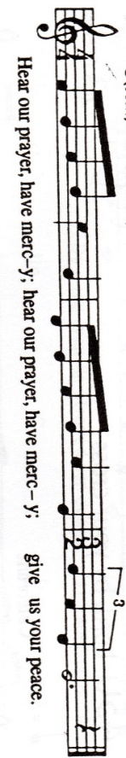
Breaking of the Bread
The priest breaks the consecrated bread.
We break this bread
to share in the body of Christ.
Though we are many, we are one body,
because we all share in one bread.

Please SIT or KNEEL
The Agnus Dei

Giving of Communion
This is the Lamb of God
who takes away the sin of the world.
Blessed are those who are called to his supper.
Lord, I am not worthy to receive you,
but only say the word, and I shall be healed.

COMMUNION HYMN

Soul of my Saviour sanctify my breast,
Body of Christ, be thou my saving guest,
Blood of my Saviour, bathe me in thy tide,
Wash me with water flowing from thy side.

Strength and protection may thy passion be,
O blessèd Jesu, hear and answer me;
Deep in thy wounds, Lord, hide and shelter me,
So shall I never, never part from thee.

Guard and defend me from the foe malign,
In death's dread moments make me only thine;
Call me and bid me come to thee on high
Where I may praise thee with thy saints for ay.

POST COMMUNION PRAYER
God of love, may the death and resurrection of Christ which we have celebrated in this Holy Eucharist bring us, with all the faithful departed,
into the peace of your eternal home.
We ask this in the name of Jesus Christ,
our rock and our salvation. To whom be glory for time and for eternity. Amen.

Father of all, we give you thanks and praise,
that when we were still far off you met us
in your Son and brought us home.
Dying and living, he declared your love,
gave us grace, and opened the gate of glory.
May we who share Christ's body
live his risen life;
we who drink his cup bring life to others;
we whom the Spirit lights give light to the world.
Keep us firm in the hope
you have set before us,
so we and all your children shall be free,
and the whole earth live to praise your name;
through Christ our Lord. Amen.

THE SOLEMN BLESSING

The Lord be with you.
And also with you.

God the Father, by whose love Christ was raised from the dead, open to you who believe the gates of everlasting life. Amen.

God the Son, who in bursting the grave has won a glorious victory, give you joy as you share the Easter faith. Amen.

God the Holy Spirit, whom the risen Lord breathed into his disciples, empower you and fill you with Christ’s peace. Amen.

And the blessing of God almighty,
the + Father, the Son, and the Holy Spirit,
be among you and remain with you always.
Amen.

DISMISSAL

Neither death nor life can separate us from the love of God in Jesus Christ our Lord.

Go in peace to love and serve the Lord.
In the name of Christ, Amen.

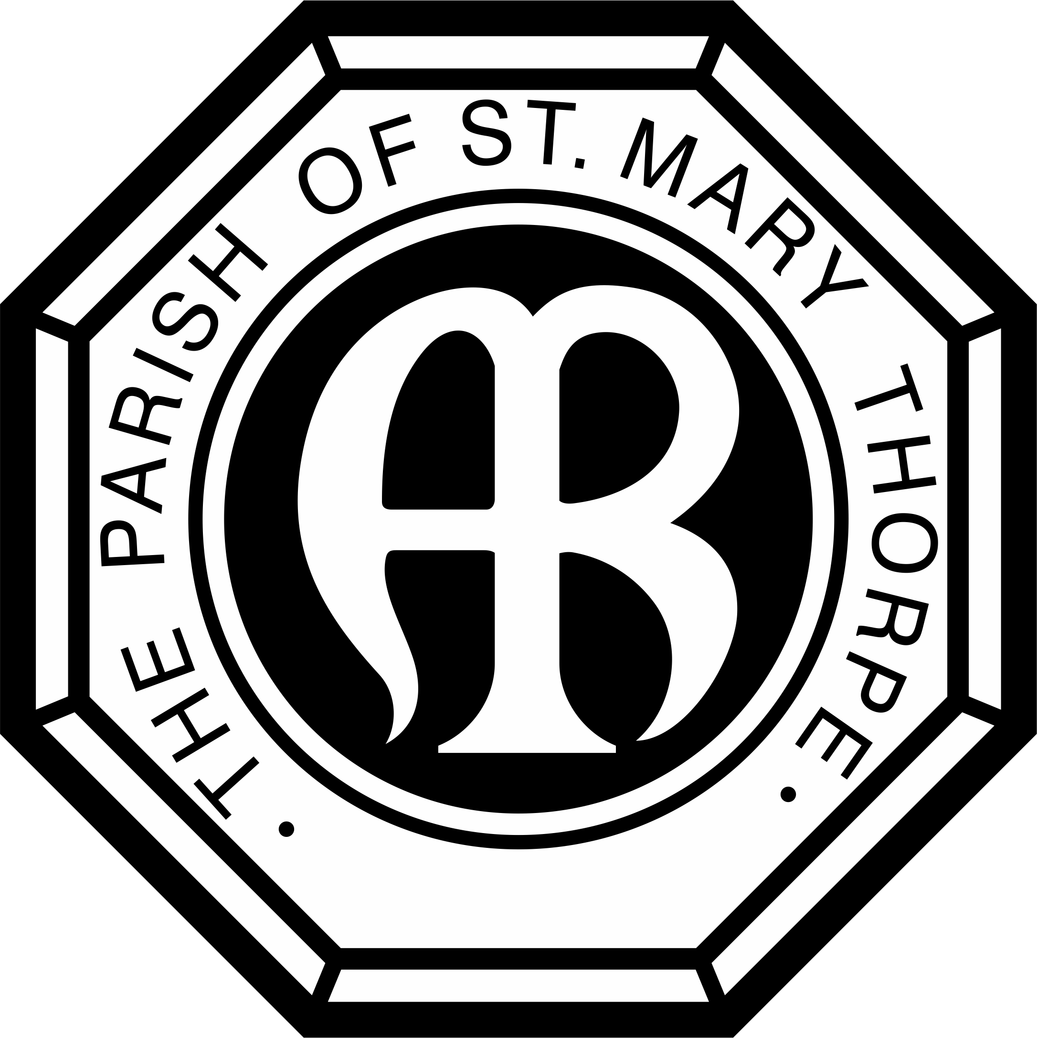
HYMN
Ye holy angels bright,
who wait at God's right hand,
or through the realms of light
fly at your Lord's command,
assist our song, for else the theme,
too high doth seem
for mortal tongue.

Ye blessed souls at rest,
who ran this earthly race
and now, from sin released,
behold your Saviour's face,
his praises sound,
as in his sight with sweet delight
ye do abound.

Material is copyright: Common Worship 2000 & Times & Seasons 2006 © & Festivals 2006 - Archbishop’s Council. Psalm Music © Thorpe Parochial Church Council 2019.

Ye saints, who toil below,
adore your heavenly King,
and onward as ye go some joyful anthem sing;
take what he gives and praise him still,
through good or ill,
who ever lives!

My soul, bear thou thy part,
triumph in God above:
and with a well-tuned heart
sing thou the songs of love!
Let all thy days till life shall end,
whate'er he send,
be filled with praise!

