Faith Confirmed 2019
THINKING ABOUT PRAYER
In this part of Emmaus, we will be thinking about how Christians grow: through prayer, reading the Bible, fellowship and worship (especially through Holy Communion).
We follow the example of the early Christians who devoted themselves to the apostles’ teaching and fellowship, to the breaking of bread and the prayers. (Acts 2.42)
Knowledge of Jesus is the beginning of our understanding of God. Knowledge and understanding come through our prayer life, which should arouse our love and longing for God.

The Parable of the sower Luke 8.1-15
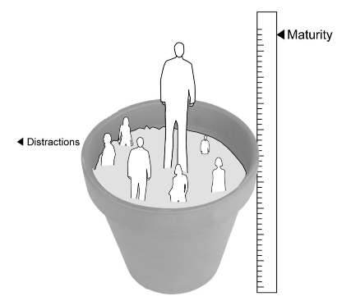
‘A sower went out to sow his seed; and as he sowed, some fell on the path and was trampled on, and the birds of the air ate it up. Some fell on the rock; and as it grew up, it withered for lack of moisture. Some fell among thorns, and the thorns grew with it and choked it. Some fell into good soil, and when it grew, it produced a hundredfold.’ As he said this, he called out, ‘Let anyone with ears to hear listen!’

Jesus tells this story to teach us lessons about how Christians grow to maturity and what dangers and distractions to expect.
- The seed on the path
- The seed on the rock
- The seed among thorns
- The seed on good soil

‘Now the parable is this: The seed is the word of God. The ones on the path are those who have heard; then the devil comes and takes away the word from their hearts, so that they may not believe and be saved. The ones on the rock are those who, when they hear the word, receive it with joy. But these have no root; they believe only for a while and in a time of testing fall away. As for what fell among the thorns, these are the ones who hear; but as they go on their way, they are choked by the cares and riches and pleasures of life, and their fruit does not mature. But as for that in the good soil, these are the ones who, when they hear the word, hold it fast in an honest and good heart, and bear fruit with patient endurance.’

Lord, teach us to pray Luke 11.1
Jesus was praying in a certain place, and after he had finished, one of his disciples said to him, ‘Lord, teach us to pray, as John taught his disciples.’

Jesus responds to the disciples’ question by giving them his own prayer which the foundation for every Christian’s life of prayer is:
Our Father in heaven, or Our Father, who art in heaven,
hallowed be your name, hallowed be thy name;
your kingdom come, your will be done, thy kingdom come; thy will be done;
on earth as in heaven. on earth as it is in heaven.
Give us today our daily bread. Give us this day our daily bread.
Forgive us our sins And forgive us our trespasses,
as we forgive those as we forgive those
who sin against us. who trespass against us.
Lead us not into temptation And lead us not into temptation;
but deliver us from evil. but deliver us from evil.
For the kingdom, the power, For thine is the kingdom,
and the glory are yours the power and the glory,
now and for ever. Amen. for ever and ever. Amen.
Jesus encourages the disciples to develop good habits of personal prayer…
Whenever you pray, go into your room and shut the door and pray to your Father
who is in secret; and your Father who sees in secret will reward you. (Matthew 6.6)
… and of prayer together:
Where two or three are gathered in my name, I am there among them.(Matthew 18.20)

Some first steps in Prayer
Here are some steps you can take to establish a daily time of prayer:
- Find the time.
- Find the place.
- Plan the time.
There is no single, ‘right’ way to pray that suits everyone. Some people use Bible reading notes as a framework. Others use a simple outline for prayer called a ‘Daily Office’ (at St Mary’s we use Common Prayer every morning). The best guide is to
discover what helps you and to use that. There are different ways of planning a daily prayer time. This is one way that many have found helpful. Divide your time into three parts:
- preparing (through praise, confession and stillness);
- listening (through attending to Scripture);
- talking (prayers on behalf of the world and yourself).

Regular Prayer
Think about how you might develop a helpful pattern of prayer. Try to learn
the Lord’s Prayer by heart and pray it slowly each day, thinking carefully
about the words. There are many ways to pray; growth in holiness begins with each of us finding the way that suits us best. Essentially, prayer should not be cerebral – simply of the mind, but it should engage our heart and mind together – enliven our soul, that spiritual space within each one of us.

All prayer, in word or in action, or in thought, draws the company of the Church on earth into communion. Prayer brings Christians together in unity, both the living, and the departed – which the New Testament calls the Saints. So even when you feel alone, you are never alone in prayer, for there is always someone else praying with you, therefore we never pray alone. If you do struggle, be natural and persevere. Like anything else, prayer becomes easier with practice. Sometimes, you just need to be still and allow yourself to fall into the presence of God.

Be still and know that I am God! (Psalm 46.10)

Praying with others
One way in which God speaks to us is through the Bible, most especially the Gospels. People are unique – they hear the words of God and respond in different ways. Some may find reasons to reject it while others find that life causes them to drift from God’s love. But some remain faithful and flourish. The following pointers may help:
- Keep your prayers short and to the point.
- Pray so that others can hear.
- Don’t worry about how others pray.

Give your prayers a beginning, a middle and an end and finish with ‘Amen’.
"Jesus prayed briefly when He was in a crowd;
He prayed a little longer when He was with His disciples;
and He prayed all night when He was alone.”
Billy Graham, evangelist and teacher.

Prayer – our living life of love
Prayer is essential to the Christian life, because it builds our relationship with God, through Jesus. Like any relationship of love, communication is the key essential. But it is not always easy, and we can each communicate uniquely.

- Prayer builds up our friendship with God. Like any relationship, our relationship with God will develop and grow as we spend quality time on building friendship. We need to allow, or even make time for prayer.
- Prayer was vital to Jesus and his ministry (Mark 1.35). He taught us to pray the Lord’s Prayer. He prayed in the Garden before his arrest. He would take himself off to pray – he wanted to be close to God, his Father.
- When we spend time with people we are shaped by them and their experience. The same is true of God. When we wait upon God in prayer, our lives are shaped by his love for us.
- Prayer also strengthens us for our daily lives. We can bring before God all sorts of things that have weighed us down or troubled us. This can help us to work out what is right. We need to trust God with our lives and pray for his guidance.
- We need to say thank you in our prayers. Prayer is an opportunity to thank God for his blessings and the joy of being alive, the bounty of creation, and of course the gift of Jesus who came among us. Prayer and praise are important aspects of Worship in the bible and in the church today.
- It is through prayer that God’s power is realised in the world today. It is through prayer that the Church can realise God’s will and direction.
- Prayer is our ‘earthing’ to God.

Types of Prayer – five examples

- Petition: asking God for…
- Thanksgiving/praise; thanking God for his blessings.
- Penitential; saying sorry
- Intercession; praying for others and their needs
- Meditative; listening to God and allowing music,
the text of the Bible and silence to inform our mind,
heart and soul.

In addition to the bible, people use all kinds of things to help them in their prayer such as art, icons, poetry, music, the natural world and so much more that can help us have something to hold, or to look at.
Prayer aids:
Candles, rosary beads, icons, statues, pictures, prayer cards, a prayer rope, a holding cross and so much more.

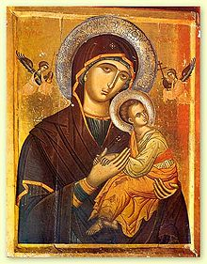
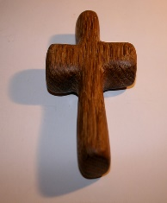
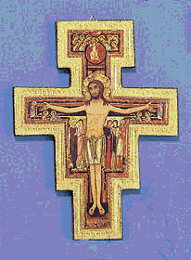
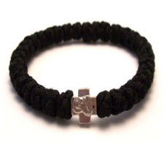
Don’t be afraid of the things that may help you to pray! If they help us in our prayer life and help us get closer to God then they are good, but not all will be right for each one of us and we need to find the things that will deepen our prayer life.
This Photo by Unknown Author is licensed under CC BY-ND

