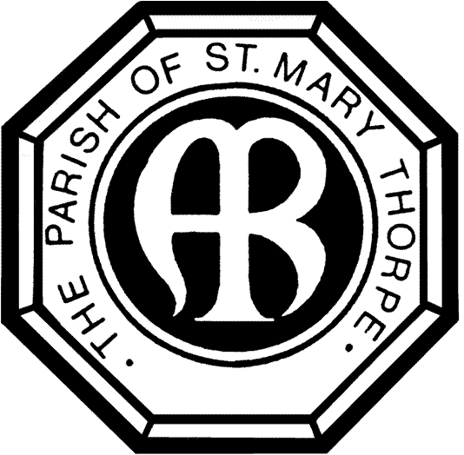
St Mary’s Church, Thorpe
Church Approach, Egham, Surrey, TW20 8TQ
Charity: 1176929. Vicar: The Revd. Damian Stewart Miles, BTh
www.stmaryschurchthorpe.co.uk

St Mary’s Church, Thorpe - Buddy Up Scheme
During the Coronavirus (COVID-19) pandemic we are unable to meet for corporate worship and fellowship. We are also unable to carry out pastoral visiting as we had previously. However, the Church is not the building, it is the people! At St Mary’s we have various plans to help us continue our ability to be church, to be the family of Christ in the coming months. Details of shared worship times (simultaneously broadcast on our Facebook page), weekly newssheet, weekly family activity packs, and other resources will be available on our website, emailed out to people, and shared by post with those without computer access, as far as we are able.
This document outlines how we intend to undertake pastoral care of each other and maintain fellowship. During this period requiring social distancing and, for some, social isolation, there is no need for all contact to cease. We may not be able to meet in person, but we can still speak to each other on the telephone to provide friendship and support – this is especially important for those who are not connected to the internet.
You have received this document because you have indicated either that you want to be on the ‘buddy up’ scheme, or because you have already either requested to receive our weekly newsletter, or are on our church electoral roll. To take part you need to opt into this scheme by an email to stmaryschurchthorpe@outlook.com saying “opt me into buddy-up 2020.”
How the scheme works
- Someone from church will telephone you at least once a week.
- You, in turn, are asked to telephone 2 other people, at least once a week.
NB. This is purposefully not daily, to ensure people are not overwhelmed, nor suffer compassion fatigue.
NB 2. This is not a scheme specifically for arranging deliveries of food or other essential items. Such systems will be set up separately.
NB 3. You may like to arrange a specific regular day or time
What can I talk about?
Suggestions:
- Obviously check in on how people are, physically and emotionally
- What positive things are they enjoying at the moment, e.g. is there a particular flower coming out in their garden, have they enjoyed a specific film or TV show?
- Are there any things they are struggling with? Even if you cannot help (and that is quite possible, and okay), just talking about it can provide some support
- You could pray together. If you are unsure or not used to praying extempore, use the Lord’s Prayer and/or the weekly Collect (on the weekly newssheet).
- If they are not online, you may like to share with them news or things you have read on the newsletter, church website or Facebook page.
- You may like to finish your conversation with the blessing of the Grace (‘The grace of our Lord Jesus Christ, and the love of God, and the fellowship of the Holy Spirit, be with us all, ever more, Amen’).

St Mary’s Church, Thorpe
Church Approach, Egham, Surrey, TW20 8TQ
Charity: 1176929. Vicar: The Revd. Damian Stewart Miles, BTh
www.stmaryschurchthorpe.co.uk

Dear

Thank you for taking part in St Mary’s Thorpe’s ‘Buddy Up’ Scheme.

Please will you phone the following 2 people, once a week:

Name –

Telephone Number –

Name –

Telephone Number –

You will be called by –

Name –

Telephone Number –

Please be assured that your contact details are only being shared with these people and your data is kept secure in accordance with GDPR and safeguarding best practice. Our policies can be found on: https://www.stmaryschurchthorpe.co.uk/policies and https://www.stmaryschurchthorpe.co.uk/safeguarding

Please let the Church Office know if you have any difficulties or wish to withdraw from the scheme. We can be contacted on:

stmaryschurchthorpe@outlook.com

01932 565986

Visit www.stmaryschurchthorpe.co.uk for the most up to date information.
and our Facebook page: https://www.facebook.com/StMarysChurchThorpe/

St Mary’s Church is following all Church of England Guidance and more information can be found at:
https://www.churchofengland.org/more/media-centre/coronavirus-covid-19-guidance-churches

